**CSP 586 Software Modeling Development with UML**

**Project Statement:** Sports Hub to buy sports tickets for different sports events in different cities for different games and leagues.

**By:-**

**Team 3**

Miraj Vekaria (A20504946)

Hemanth Thathireddy (A20525346)

**Project overview Statement:**

The Sports Hub project aims to develop a web-based platform that allows users to purchase tickets for various sporting events in various cities, for various games and leagues, and also allows event organizers to register their events on the platform. The platform will have an easy-to-use interface that allows users to search for and filter events based on location, date, team, and league. Users will be able to view available seats, choose and purchase tickets, and receive email confirmation and e-tickets. To ensure seamless transactions and secure payment processing, the platform will integrate with third-party ticketing providers and payment gateways. The Sports Hub will use cutting-edge web technologies to provide users with a fast and responsive experience, allowing them to quickly find and purchase tickets for their favorite sporting events.

**Features List**:

1. Sign up and Login

* New users can create an account by providing Name, email, password. An existing user can log in using the email and password. Also, event organizers can create an account by providing the same information.
* Visibility: Visible to user

1. Browse sports events by league, Game or city name

* Users can search for any sports event by Name, City name or league name by using the search bar.
* Visibility: Visible to user

1. View event information

* By clicking on the game, the User can see the information about the game venue, Date, ticket prices, and league name.
* Visibility: Visible to user

1. Seat selection and get tickets

* Users can select seats from available seats and add them to cart.
* Visibility: Visible to user

1. Pay through many tenders

* After choosing tickets, users can pay through many options such as credit card, debit card, Apple Pay or PayPal.
* Visibility: Visible to user

1. Get tickets in email

* After successful checkout, users will get their tickets on their email.
* Visibility: Not visible to user

1. See seating arrangements for specific events

* Users can see the seating arrangements when choosing the tickets.
* Visibility: Visible to user

1. Notify subscribed users about upcoming events

* Subscribed Users will get email notification about upcoming events.
* Visibility: Not visible to user

1. Cancel or modify tickets

* Users are able to cancel the tickets and modify the seats only if it is allowed by the event organizer.
* Visibility: Visible to user

1. Support via email, phone or live chat.

* Users can contact us when they require assistance regarding their order or in case of any issue occurs.
* Visibility: Visible to user

1. Can see order History

* Registered users can see their past purchases and also can see the upcoming purchases
* Visibility: visible to user

1. Can add/modify/delete events

* Event organizers can create/ modify / delete an event. Apart from that, they can provide information about events such as Name , location, Date and time.
* Visibility: Visible to event organizers.

**Requirements**:

1. Users must be able to search for any sports events by league name or by city and by game.
2. The platform must offer comprehensive details about each event, including the location, the time and day, the teams and players, and the cost of tickets.
3. The platform must show venue seating arrangements and enable users to choose particular seats.
4. The platform needs to provide a shopping cart feature that lets consumers add numerous tickets and pay for them all at once.
5. To securely accept credit/debit card, Apple Pay or PayPal payments, the platform must integrate with a payment gateway.
6. The platform must email to confirm the transaction.
7. Users must be able to see their account's previous and future transactions on the platform.
8. According to venue and league rules, the platform must have a cancellation and exchange policy. Based on the rules and policy, users must be able to cancel the tickets or modify their seats.
9. The site must give consumers the chance to sign up for alerts about upcoming events.
10. Users must be able to create the account. It's optional, if the user doesn't want to create an account, then they must be able to browse events and checkout as a guest. Event Organizers must be able to create accounts.
11. Apart from the customer, Event organizers must be able to create/ modify/ delete events.
12. Event organizers must be able to fill out all the information such as event name , location, date and time, Description. In addition, the organizer must contact support and provide a seating arrangement chart.
13. Platform must provide an accurate error message when any failure happens.
14. Platform must execute each and every operation smoothly.

**Use-Cases:**

**Actors :** User, Event Organizer, Financial Institution, Database, Support Team.

**Use-Case Text in brief format:**

1. **Registration and Login:**

User registration and login feature is used to create user accounts, where users can provide their personal information such as name, email, and password. This feature allows users to view past purchases. It also provides a secure and personalized experience for the users. Event Organizers can create an account by providing the same information. All the information of the accounts will be stored in the database.

1. **Search Events:**

This feature allows users to search for the specific event by event name , location, or date and time. It provides a convenient way to search for desired events of a user. Database has all the information of events.

1. **View Event Information:**

This feature shows event information such as location, league name , date and time, description of event to users. Database has all the information of events.

1. **Add/Update/Delete Events:**

This feature allows event organizers to register their event or modify the event information, or can delete an event on the portal. The database will update the information according to event organizer input.

1. **View, Select seats and add to cart:**

This feature allows users to view the seating chart and availability for specific events. It helps users to choose the best seats available based on their preferences and budget. And add selected seats to cart to buy at once. The Event Organizer will contact the Support team to add seating arrangements.

1. **Payment through Different Tenders** (Credit card, debit card, PayPal etc.):

This feature allows users to choose from different payment options, such as credit card, debit card, PayPal, and other payment gateways. It provides users with a flexible and convenient way to make payments for their purchases. All tenders' validity will be checked through financial institutions. And after checkout, all the transaction data will be stored in the database.

1. **Send Tickets on Email:**

This feature allows users to receive electronic tickets and confirmation email for their purchases. It helps users to keep track of their activities on the platform and also provides a secure and convenient way to access their tickets.

1. **Subscribe to receive notification for upcoming events:**

This feature allows users to receive notifications for upcoming events. It helps users to stay updated on the latest events. The database will store all the subscribed emails.

1. **Cancel/Modify tickets online:**

This feature allows users to cancel or modify tickets, if allowed by the event organizer. It provides users with a flexible and convenient way to manage their purchases. Event organizers will set rules and policy for cancellation and modification. The database will be used to validate the order.

1. **View past and upcoming purchases:**

This feature allows users to view their past and upcoming purchases in their user account. It provides users with a complete overview of their activities on the platform. Database has the information of every order of a user.

1. **Contact customer support via email, phone, or live chat:**

This feature allows users to contact customer support via email, phone, or live chat. It provides users with a way to get assistance and support for their queries and issues. Event organizer will contact the support team to add seats layout for the events.

**Use-Case in Fully Dressed Format:**

1. **Registration and login:**

| **Use case name** | User registration and login |
| --- | --- |
| **Scope** | E-commerce website |
| **Level** | User goal |
| **Primary actor** | User |
| **Stakeholders** | * **User:** The person who wants to register and log in to the e-commerce website to make purchases and access personalized information. * **Event Organizer:** The person who wants to create an account to organize events on the e-commerce website. * **System:** The e-commerce website that stores the user information and provides the registration and login feature. |
| **Preconditions** | * The user has access to the e-commerce website. * The user has a valid email address * The event organizer has a valid email address. * The system is running properly. |
| **Flow of events** | 1. The user clicks on the "Register" button. 2. The system displays a registration form. 3. The user fills in the required information such as name, email, and password. 4. The user clicks on the "Submit" button. 5. The system verifies the information and creates a new account. 6. The system displays a confirmation message. 7. The user clicks on the "LogIn" button. 8. The user clicks on the "LogIn" button. 9. The system displays a login form. 10. The user enters the username and password. 11. The system verifies the information and logs in to the account. 12. The system displays the user's personalized information and past purchases. |
| **Exception condition** | * If the user enters invalid information, the system displays an error message and prompts the user to enter valid information. * If the username is already taken, the system displays an error message and prompts the user to choose a different username. * If the user forgets the password, the system provides a "Forgot Password" feature to reset the password. |

1. **Search Events:**

| **Use Case Name** | Search Events |
| --- | --- |
| **Scope** | E-commerce website |
| **Level** | User goal |
| **Primary actor** | User |
| **Stakeholders** | * User: The person who wants to search for events on the e-commerce website. * System: The e-commerce website that stores the event information and provides the search feature. |
| **Preconditions** | * The user has access to the e-commerce website. * The system has a database that contains information about the events. |
| **Flow of events** | 1. The user clicks on the "Search Events" button. 2. The system displays a search form. 3. The user enters the search criteria such as event name, location, or date and time. 4. The user clicks on the "Search" button. 5. The system searches the database for events that match the search criteria. 6. The system displays a list of events that match the search criteria. |
| **Exception conditions** | * If no events match the search criteria, the system displays a message indicating that no events were found. * If the system is not running properly, the user cannot access the search feature. * If the user enters invalid search criteria, the system displays an error message and prompts the user to enter valid search criteria. * If the user wants to refine the search, the system provides options to modify the search criteria and search again. |

1. **View Event information:**

| **Use case name** | View Event information: |
| --- | --- |
| **Scope** | E-commerce website |
| **Level** | User goal |
| **Primary actor** | User |
| **Stakeholders** | * User: The person who wants to view information about an event on the e-commerce website. * System: The e-commerce website that stores the event information and provides the view event information feature. |
| **Preconditions** | * The user has access to the e-commerce website. * The system has a database that contains information about the events. |
| **Flow of events** | 1. The user clicks on an event from the list of events. 2. The system displays the event information, including location, league name, date and time, and description of the event.7 |
| **Exception condition** | * If the user wants to go back to the list of events, the system provides an option to go back. * If the system is not running properly, the user cannot access the event information. * If the user clicks on an event that does not exist, the system displays an error message. * If the event information is incomplete or inaccurate, the system displays a message indicating that the information is not available or correct. |

1. **Add/Update/Delete Events:**

| **Use case name** | Add/update/delete Events |
| --- | --- |
| **Scope** | E-Commerce website |
| **Level** | User goal |
| **Primary actor** | Event organizer |
| **Stakeholders** | **Event organizer:** The person who wants to add, update, or delete and event on the e-commerce website  **System:** The e-commerce website that stores the event information and provides the add,update,or delete event feature. |
| **Preconditions** | * The event organizer has access to the e-commerce website * The system has a database that contains information about the events. |
| **Flow of events** | Event organizer |
|  | 1. The event organizer logs in to the e-commerce website. 2. The event organizer clicks on the "Add/Update/Delete Events" button. 3. The system displays a form for adding, updating, or deleting an event. 4. To add a new event, the event organizer fills out the form with the event information, such as event name, location, date and time, and description, and clicks on the "Add" button. 5. To update an existing event, the event organizer selects the event to update from the list of events, modifies the information as needed, and clicks on the "Update" button. 6. To delete an event, the event organizer selects the event to delete from the list of events and clicks on the "Delete" button. 7. The system updates the database with the new or modified event information, or deletes the selected event. |
| **Exception Conditions** | * If the event organizer enters invalid or incomplete information, the system displays an error message and prompts the event organizer to correct the information. * If the system is not running properly, the event organizer Cannot access the add, update, or delete event feature. * If the event organizer does not have the necessary permissions to add, update, or delete events, the system displays an error message. * If the event organizer wants to go back to the previous page, the system provides an option to go back. |

1. **View, Select Seats and Add to cart:**

| **Use-Case Name** | View, Select Seats and Add to cart | | |
| --- | --- | --- | --- |
| **Scope** | System Use Case | | |
| **Level** | User-Goal Level | | |
| **Primary Actor** | User | | |
| **Stakeholders & Interests** |  | | |
| **Preconditions** | Seats must be available | | |
| **Postconditions** | Tickets have been added to cart. | | |
| **Flow of Events** | User | | |
|  | 1. User search for an event | | |
|  | 1. User tap on select seats | | |
|  | 1. User will select seats from available seats. | | |
|  | 1. User will add seats to the cart. | | |
| **Exception Conditions** |  | | |

**6. Payment through credit card:**

| **Use-Case Name** | Payment through Different Tenders | | |
| --- | --- | --- | --- |
| **Scope** | System Use Case | | |
| **Level** | User-Goal Level | | |
| **Primary Actor** | User, Financial Institution, Database | | |
| **Stakeholders & Interests** |  | | |
| **Preconditions** | Users must have any one of the tenders' information. | | |
|  | Users must have tickets in the cart | | |
| **Postconditions** | Payment done successfully or unsuccessfully. | | |
| **Flow of Events** | User | Financial Institution | Database |
|  | 1. User has pressed checkout |  |  |
|  | 1. User Enter all the credit card information | 2.1 Financial institutions will check the validity of credit card and also check if sufficient funds are available to purchase. | 2.2 After successful payment, all the transaction info will be stored in the database. |
| **Exception Conditions** | When a credit card is not valid, or it does not have sufficient funds to purchase tickets. | | |

1. **Send tickets on Email:**

| **Use case name** | Send tickets on Email |
| --- | --- |
| **Scope** | E-Commerce website |
| **Level** | User goal |
| **Primary actor** | User |
| **Stakeholders** | * User: The person who wants to receive electronic tickets and confirmation email for their purchases on the e-commerce website. * System: The e-commerce website that sends the electronic tickets and confirmation email to the user. |
| **Preconditions** | * The user has made a purchase on the e-commerce website. * The user has provided a valid email address during the checkout process. |
| **Flow of events** | 1. The user makes a purchase on the e-commerce website. 2. The system generates an electronic ticket and confirmation for the purchase. 3. The system sends an email to the user's provided email address with the electronic ticket and confirmation. 4. The user receives the email with the electronic ticket and confirmation. 5. The user can print the electronic ticket or show it on their mobile device to gain entry to the event. |
| **Exception condition** | * If the user did not receive the email with the electronic ticket and confirmation, the system provides an option for the user to resend the email. * If the user provided an invalid email address during the checkout process, the system displays an error message and prompts the user to provide a valid email address. * If the system is not running properly, the user cannot receive the electronic ticket and confirmation email. * If the user has any issues with the electronic ticket or confirmation, the system provides a customer support contact for assistance. |

1. **Subscribe to receive notifications for upcoming events:**

| **Use case name** | Send Tickets on Email |
| --- | --- |
| **Scope** | E-Commerce website |
| **Level** | User goal |
| **Primary actor** | User |
| **Stakeholders** | * User: The person who wants to receive electronic tickets and confirmation email for their purchases on the e-commerce website. * System: The e-commerce website that sends the electronic tickets and confirmation email to the user. |
| **Preconditions** | * The user has made a purchase on the e-commerce website. * The user has provided a valid email address during the checkout process. |
| **Flow of events** | 1. The user makes a purchase on the e-commerce website. 2. The system generates an electronic ticket and confirmation for the purchase. 3. The system sends an email to the user's provided email address with the electronic ticket and confirmation. 4. The user receives the email with the electronic ticket and confirmation. 5. The user can print the electronic ticket or show it on their mobile device to gain entry to the event. |
| **Exception condition** | * If the user did not receive the email with the electronic ticket and confirmation, the system provides an option for the user to resend the email. * If the user provided an invalid email address during the checkout process, the system displays an error message and prompts the user to provide a valid email address. * If the system is not running properly, the user cannot receive the electronic ticket and confirmation email. * If the user has any issues with the electronic ticket or confirmation, the system provides a customer support contact for assistance. |

1. **Cancel/Modify tickets online:**

| **Use case name** | Cancel/Modify tickets online |
| --- | --- |
| **Scope** | E-Commerce website |
| **Level** | User goal |
| **Primary actor** | User |
| **Stakeholders** | * User: The person who wants to cancel or modify their tickets on the e-commerce website. * Event Organizer: The entity that sets rules and policies for ticket cancellation and modification. * System: The e-commerce website that allows users to cancel or modify their tickets. |
| **Preconditions** | * The user has purchased tickets on the e-commerce website. * The event organizer allows ticket cancellation and modification. |
| **Flow of events** | 1. The user logs into their account on the e-commerce website. 2. The user navigates to their order history. 3. The system displays the user's order history. 4. The user selects the order containing the tickets they want to cancel or modify. 5. The system displays the details of the selected order, including the tickets. 6. If ticket cancellation and modification are allowed by the event organizer, the system provides options for the user to cancel or modify their tickets. 7. The user selects the tickets they want to cancel or modify. 8. If modifying the tickets, the user provides the new ticket details. 9. The system verifies that the cancellation or modification is allowed by the event organizer. 10. If the cancellation or modification is allowed, the system updates the order and sends a confirmation email to the user. 11. The user receives the confirmation email. 12. The user can view the updated order details in their order history. |
| **Exception condition** | * If the event organizer does not allow ticket cancellation or modification, the system displays a message informing the user. * If the event has passed, the user cannot cancel or modify their tickets. * If the user encounters any issues with the cancellation or modification, the system provides a customer support contact for assistance. |

1. **View past and upcoming purchases:**

| **Use case name** | View past and upcoming purchases |
| --- | --- |
| **Scope** | E-Commerce website |
| **Level** | User goal |
| **Primary actor** | User |
| **Stakeholders** | * User: The person who wants to view their past and upcoming purchases on the e-commerce website. * System: The e-commerce website that allows users to view their past and upcoming purchases. |
| **Preconditions** | * The user has created an account on the e-commerce website. * The user has made purchases on the e-commerce website. |
| **Flow of events** | 1. The user logs into their account on the e-commerce website. 2. The user navigates to their account page. 3. The system displays the user's account page. 4. The user selects the "My Orders" option. 5. The system displays the user's past and upcoming purchases. 6. The user can select a specific order to view more details, such as the order date, order status, and purchased items. 7. The user can view upcoming purchases and their expected delivery date. |
| **Exception condition** | * If the user has not made any purchases, the system displays a message informing the user. * If the user encounters any issues with viewing their past and upcoming purchases, the system provides a customer support contact for assistance. |

1. **Contact customer support via email, phone, or live chat:**

| **Use case name** | Contact customer support via email, phone, or live chat |
| --- | --- |
| **Scope** | E-Commerce website |
| **Level** | User goal |
| **Primary actor** | User |
| **Stakeholders** | * User: The person who wants to contact customer support for assistance or support. * Customer Support: The team responsible for providing assistance and support to users. |
| **Preconditions** | * The user has an issue or query that they need assistance or support with. |
| **Flow of events** | 1. The user navigates to the customer support page on the e-commerce website. 2. The user selects the preferred method of contact - email, phone, or live chat. 3. If the user selects email: 4. The system displays a form for the user to fill out with their name, email address, subject, and message. 5. The user fills out the form and submits it. 6. The system sends an email to the customer support team with the user's information and message. 7. The user receives a confirmation message that their email has been sent. 8. If the user selects phone:   The system displays the customer support phone number.   1. The user calls the phone number and is connected to a customer support representative. 2. The customer support representative assists the user with their issue or query. 3. If the user selects live chat: 4. The system displays a live chat window. 5. The user enters their name, email address, and message. 6. The user is connected to a customer support representative via live chat. 7. The customer support representative assists the user with their issue or query. |
| **Exception condition** | * If the user encounters any issues with contacting customer support, the system provides alternative contact methods or directs the user to an FAQ page. * If the event organizer contacts customer support to add seats layout for an event, the customer support team will assist the organizer with their request. |

**Use Case Diagram**

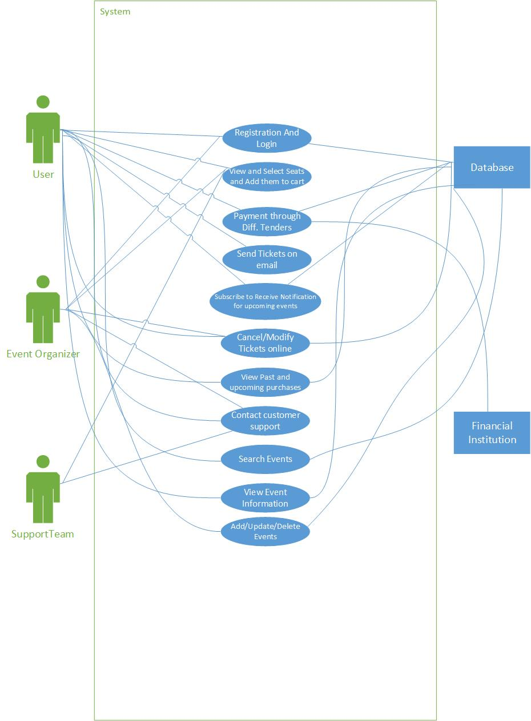

**ActivityDiagrams**

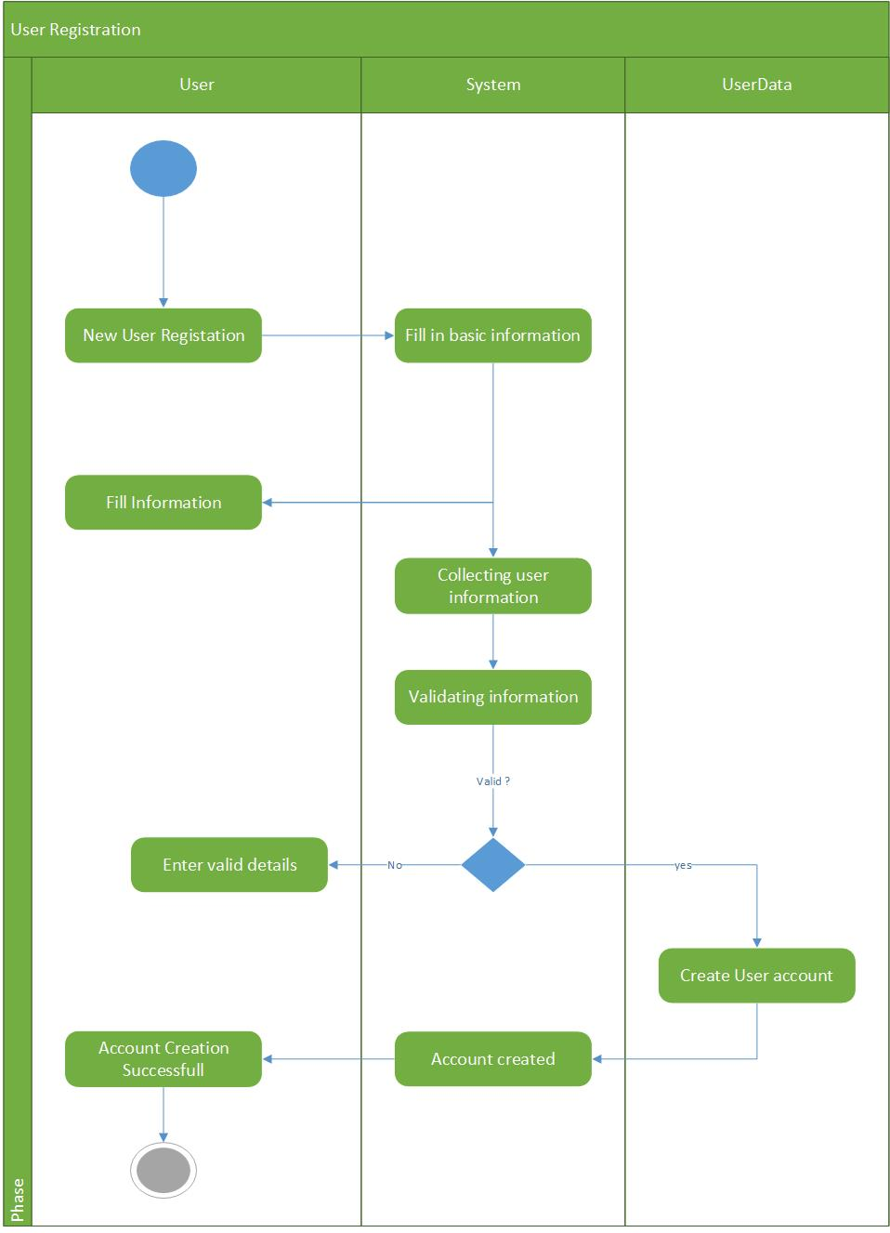

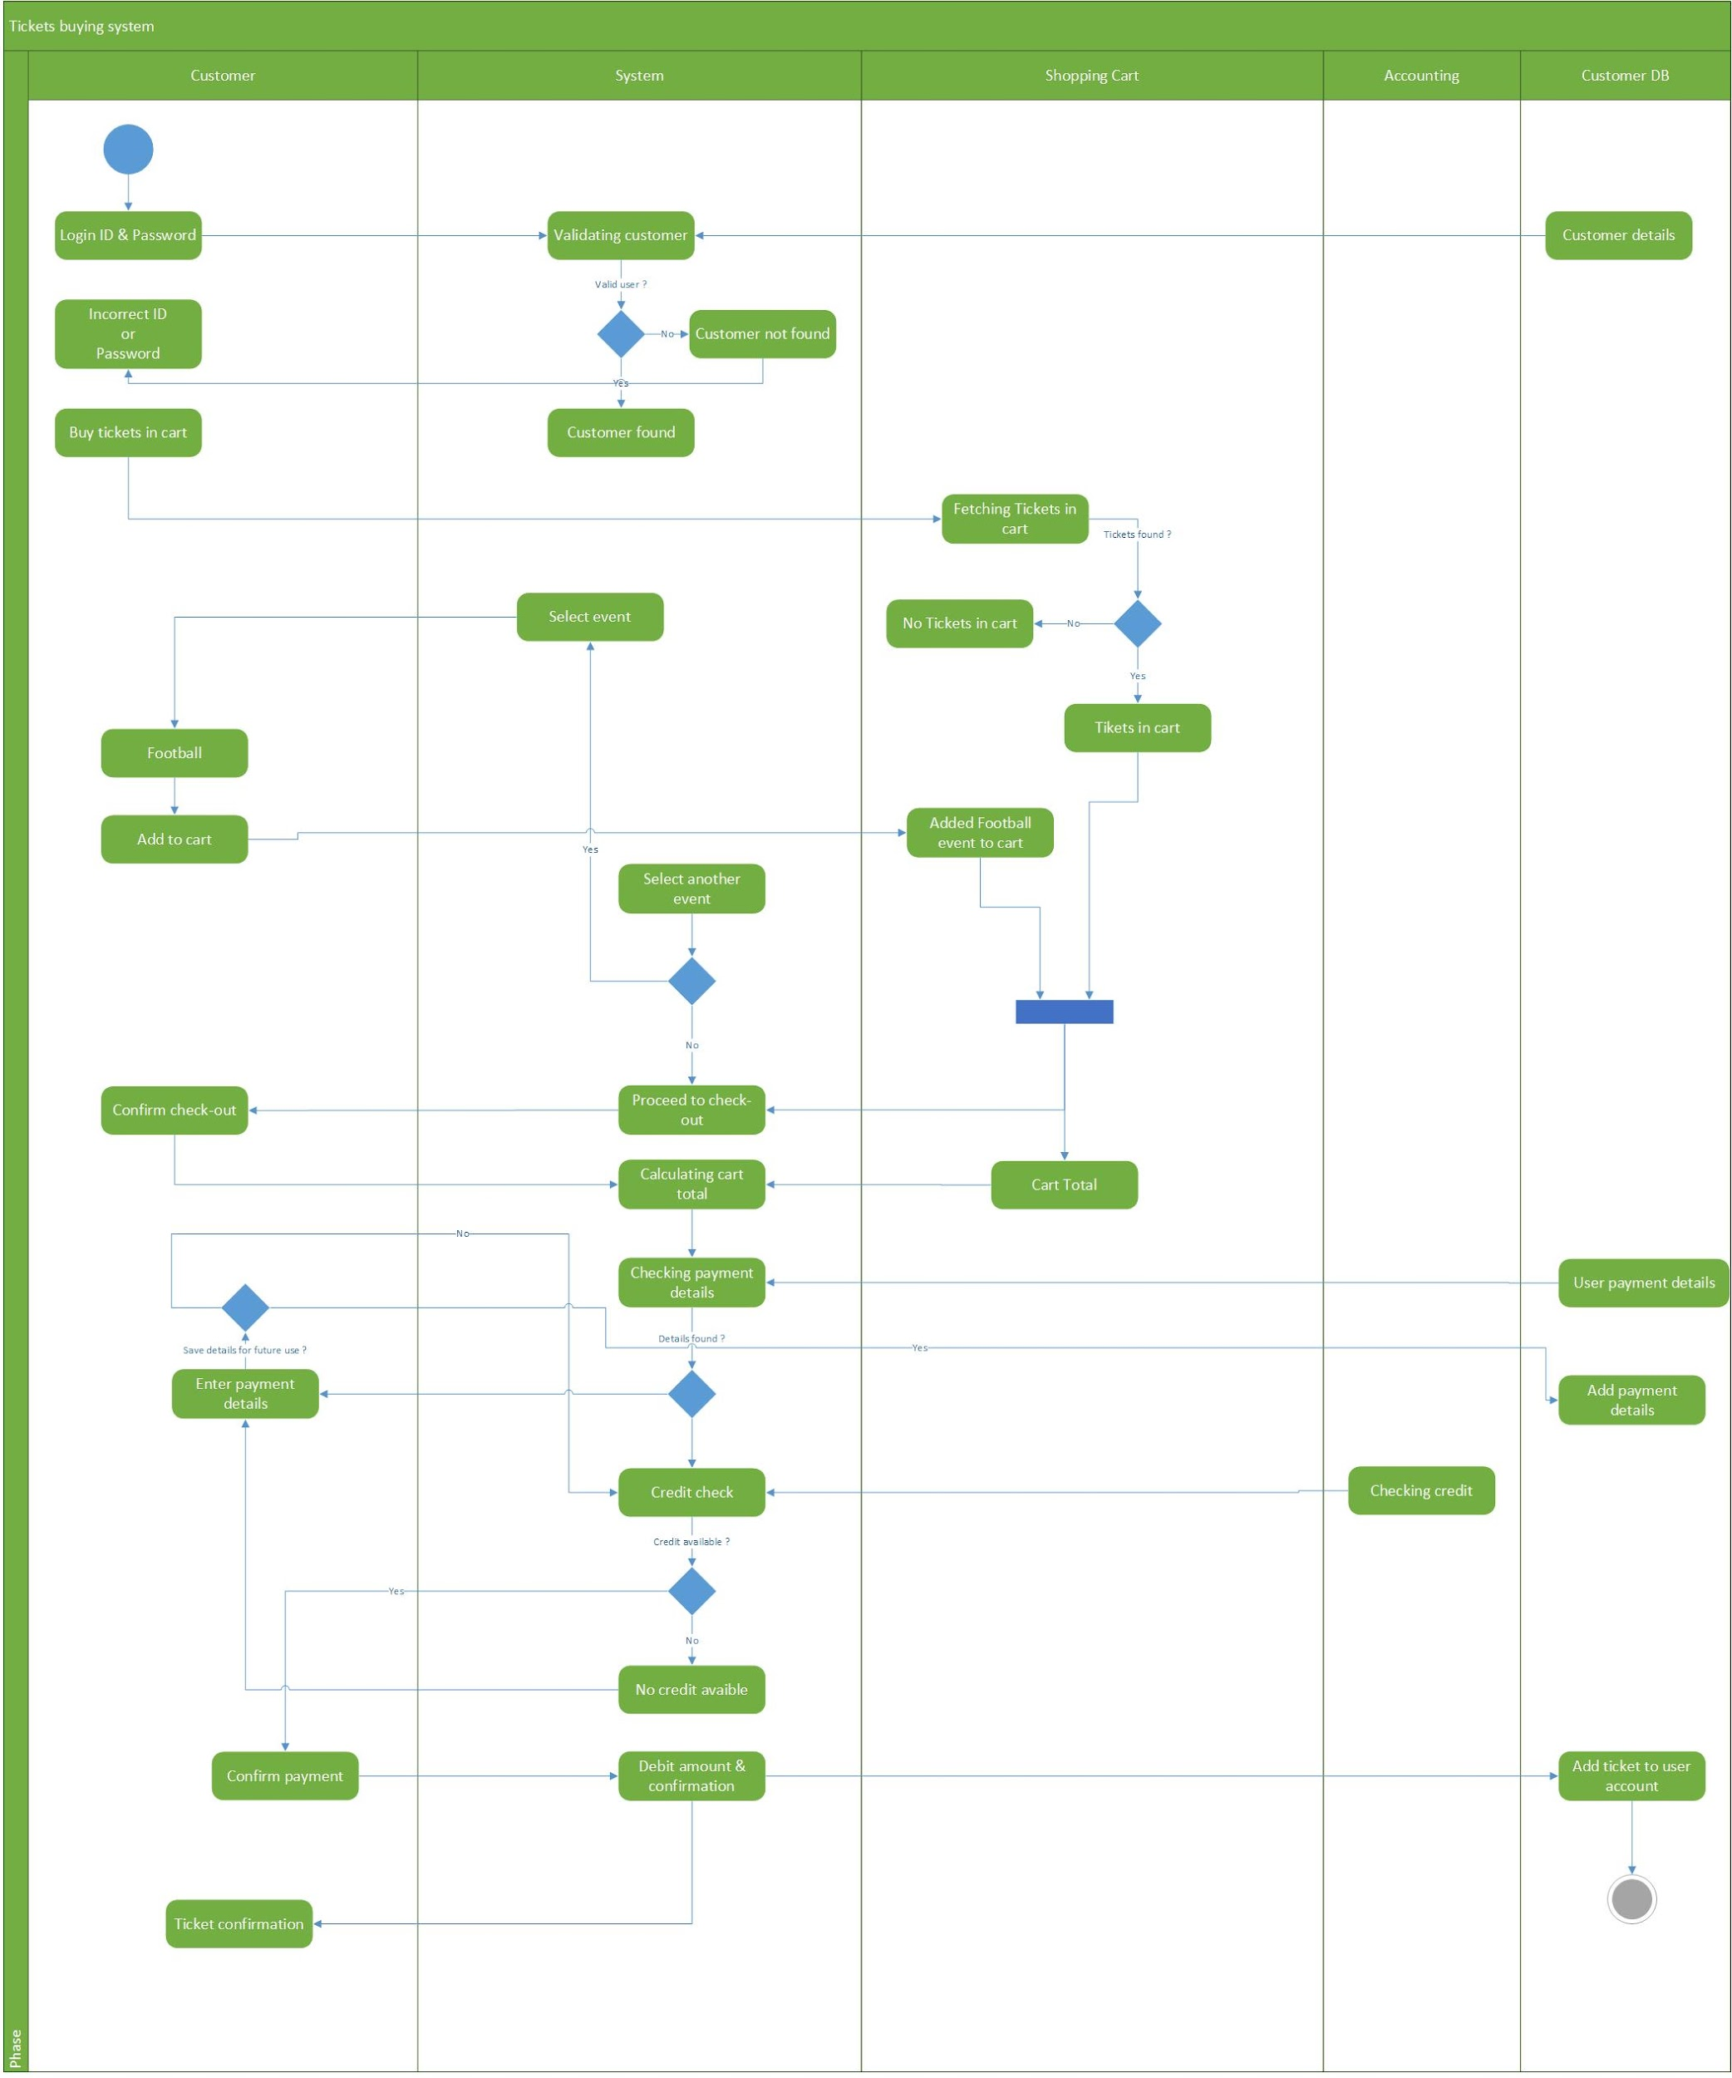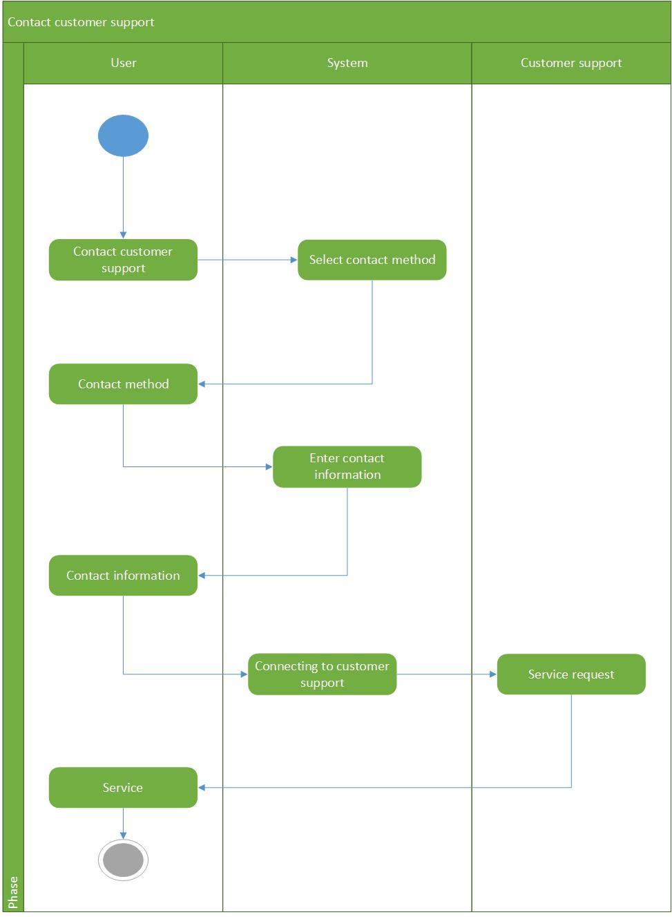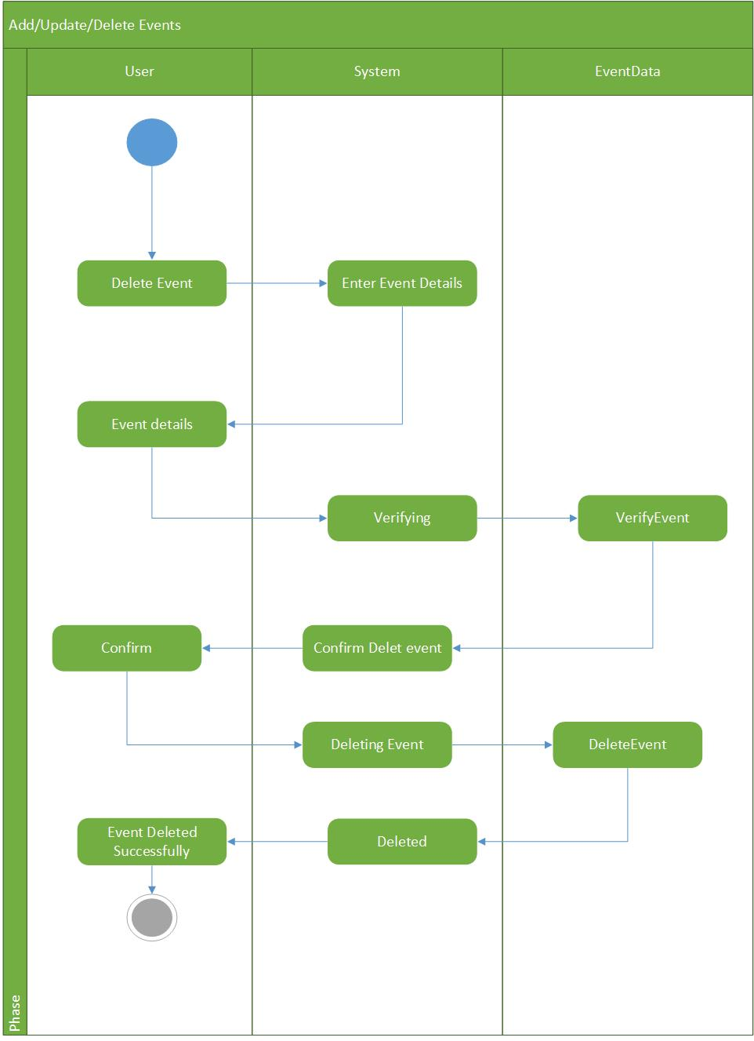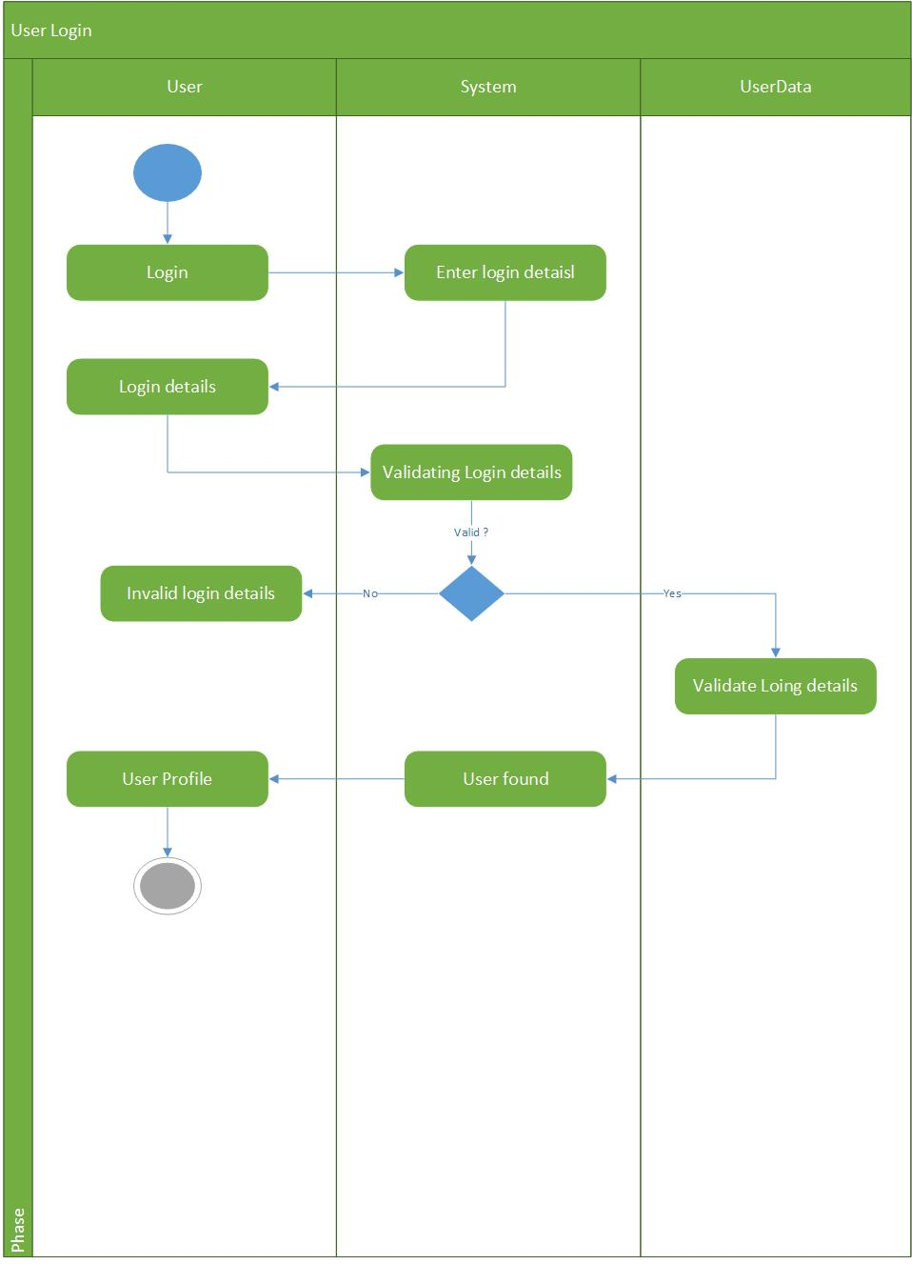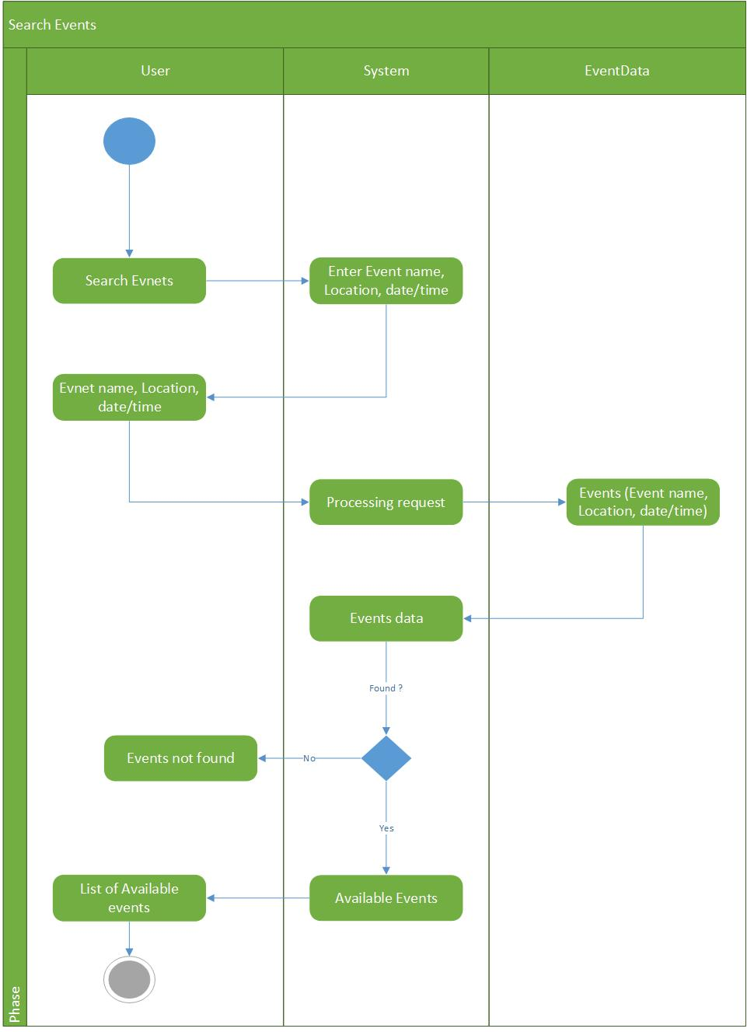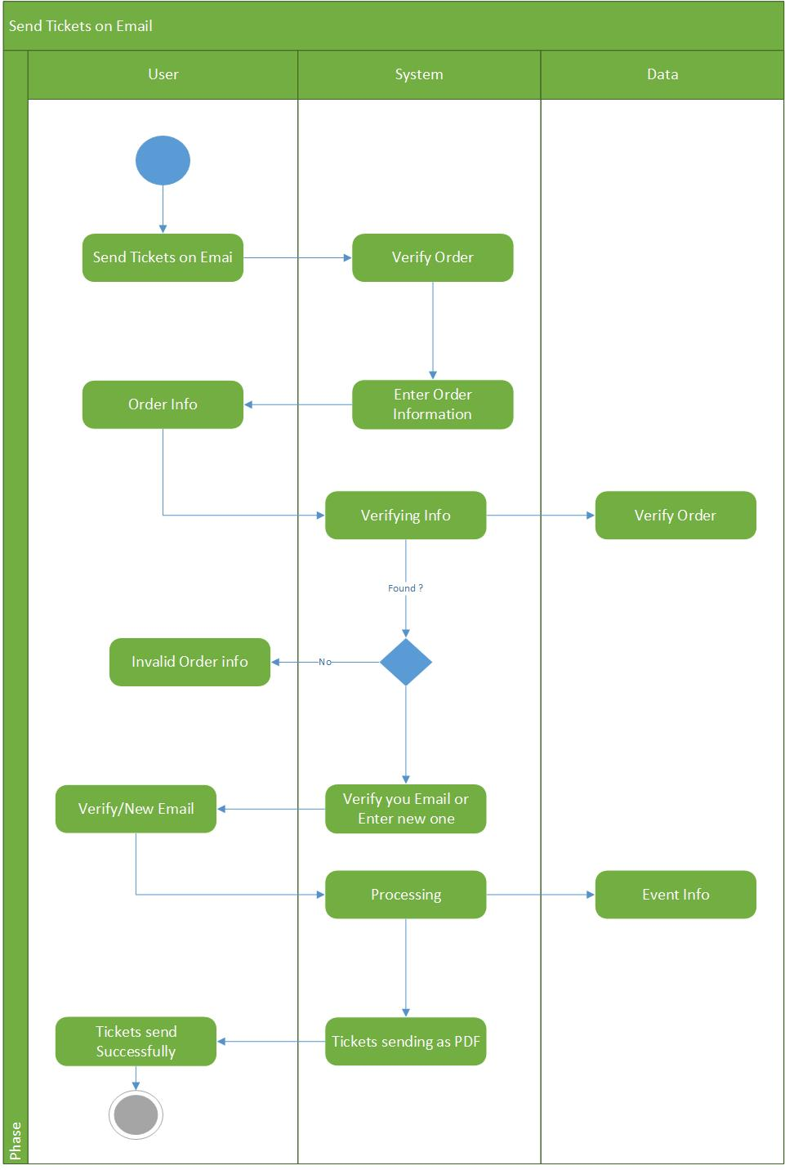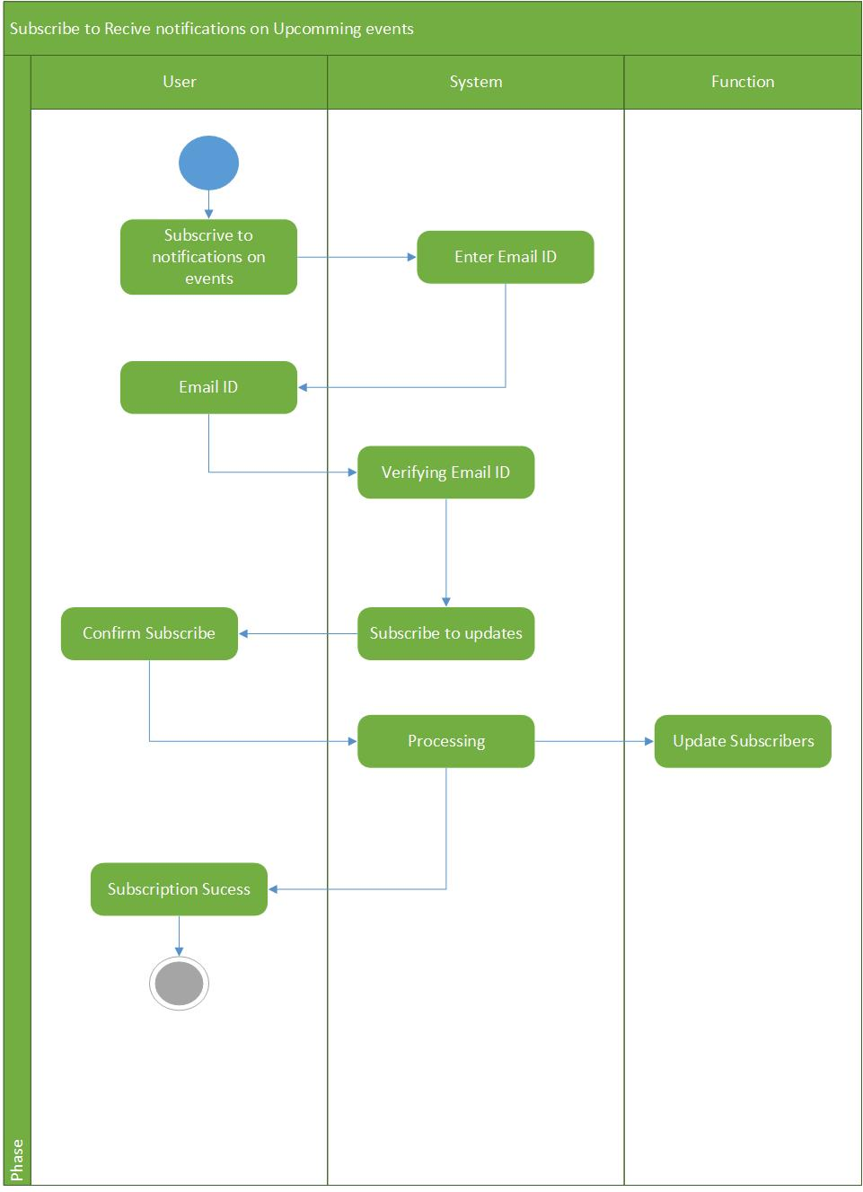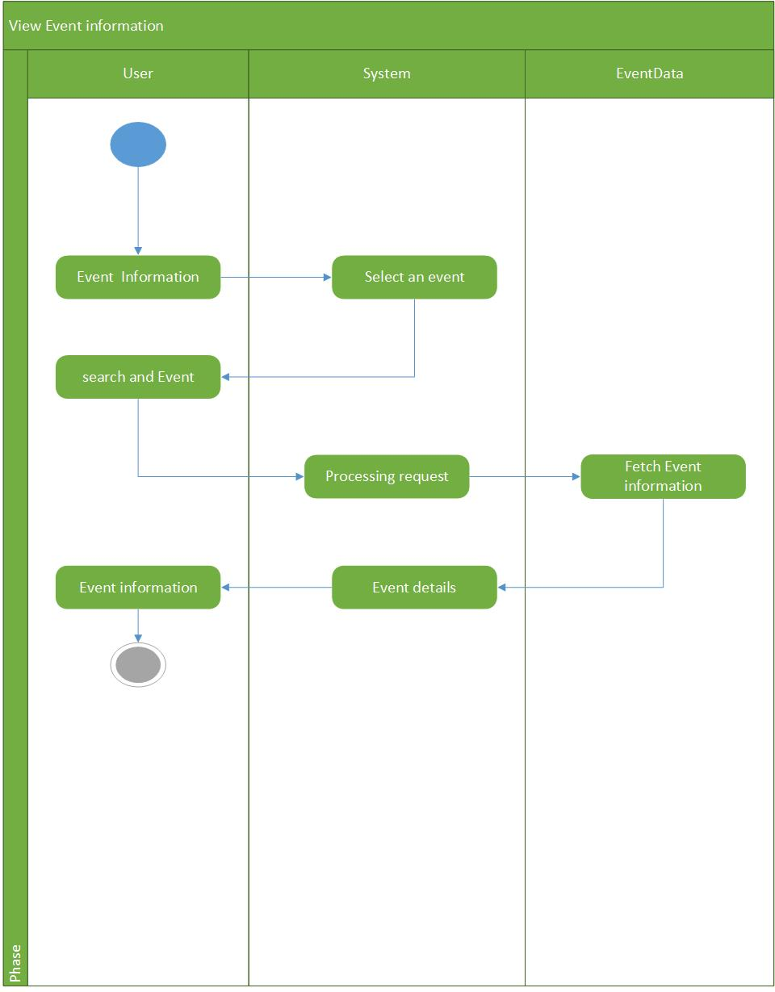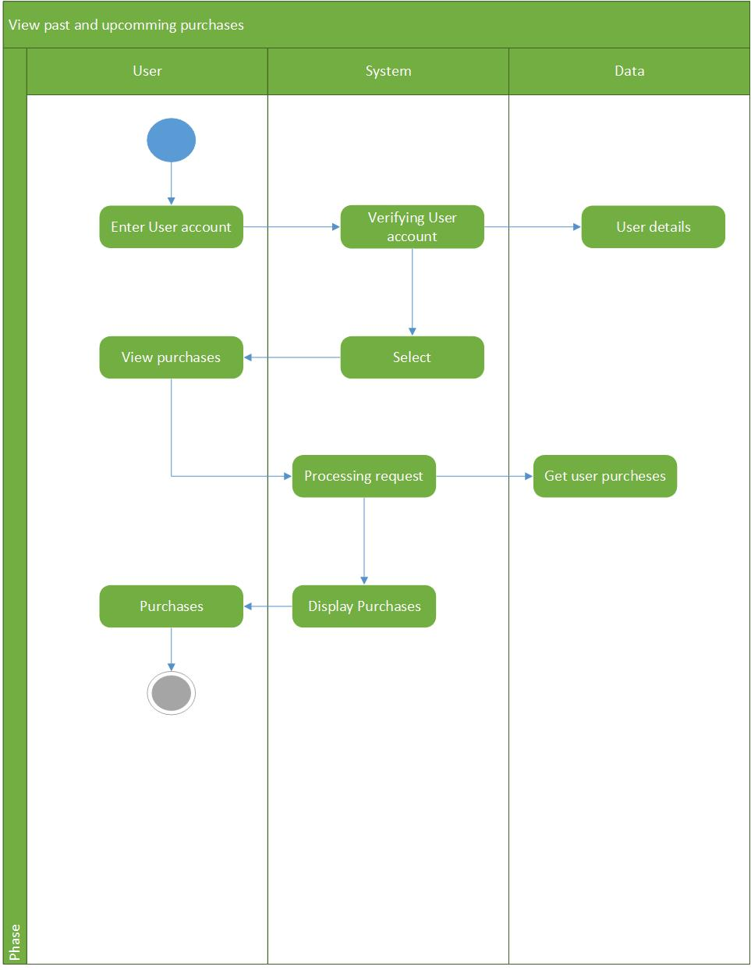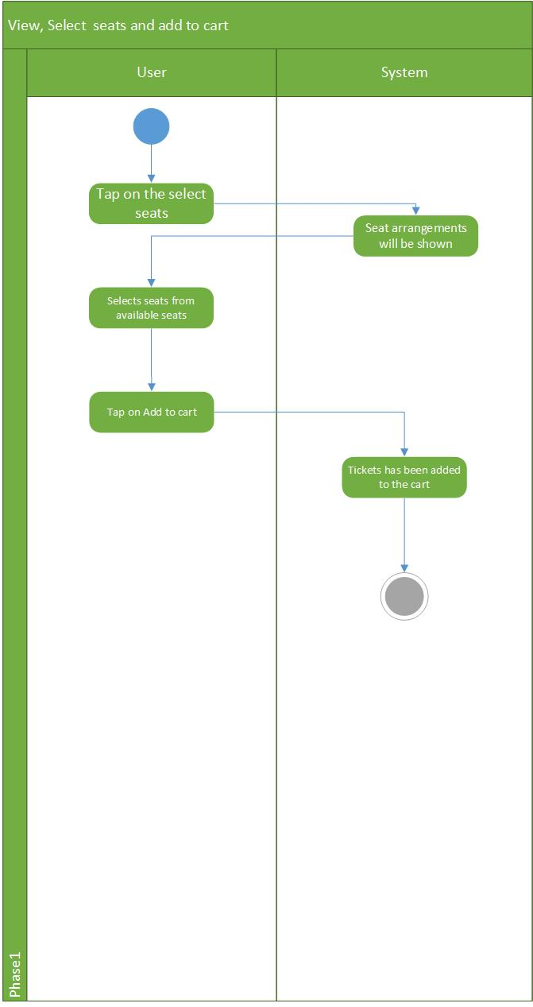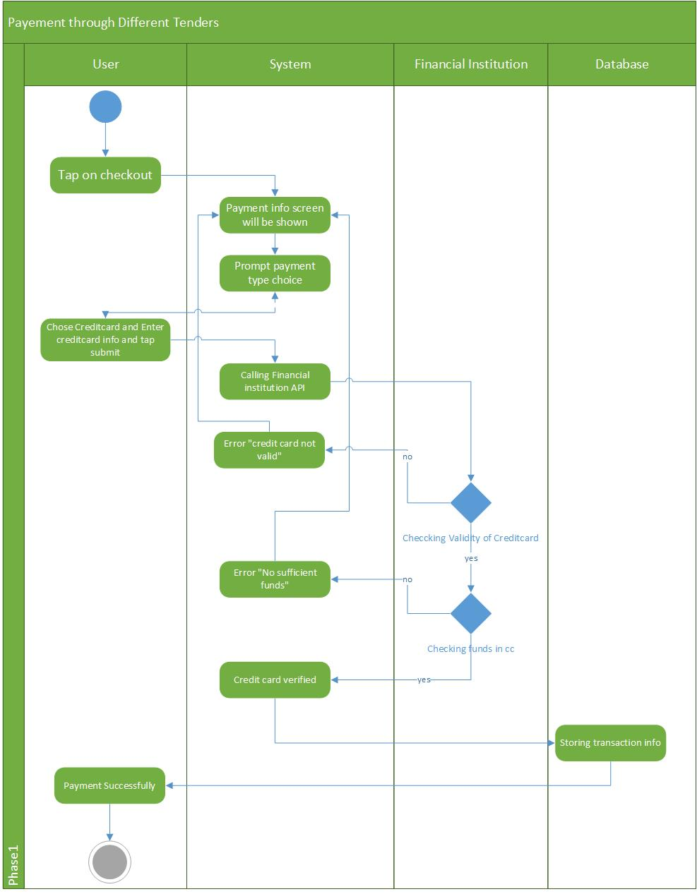

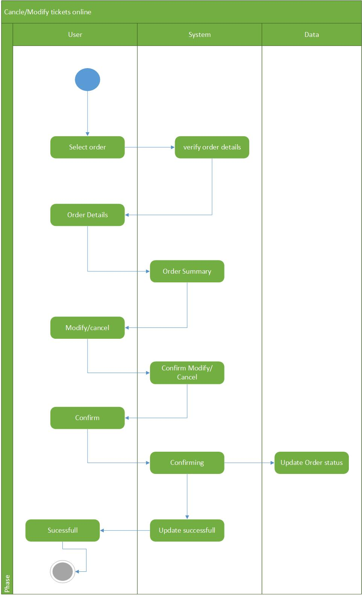

**Analysis conceptual class diagram**

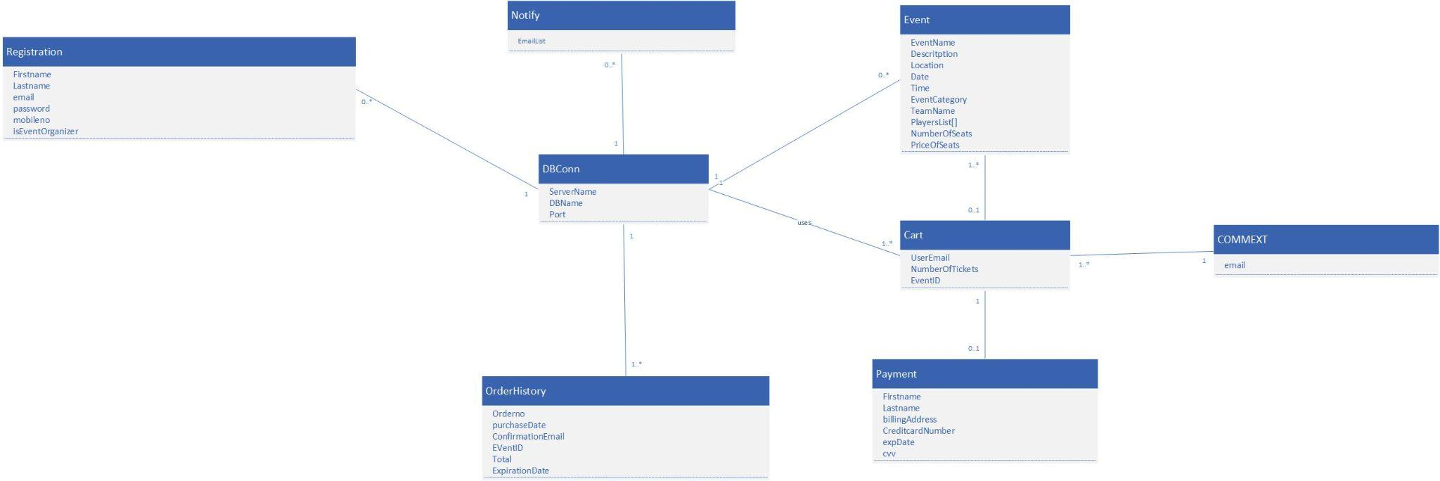

**Design Class Diagram**

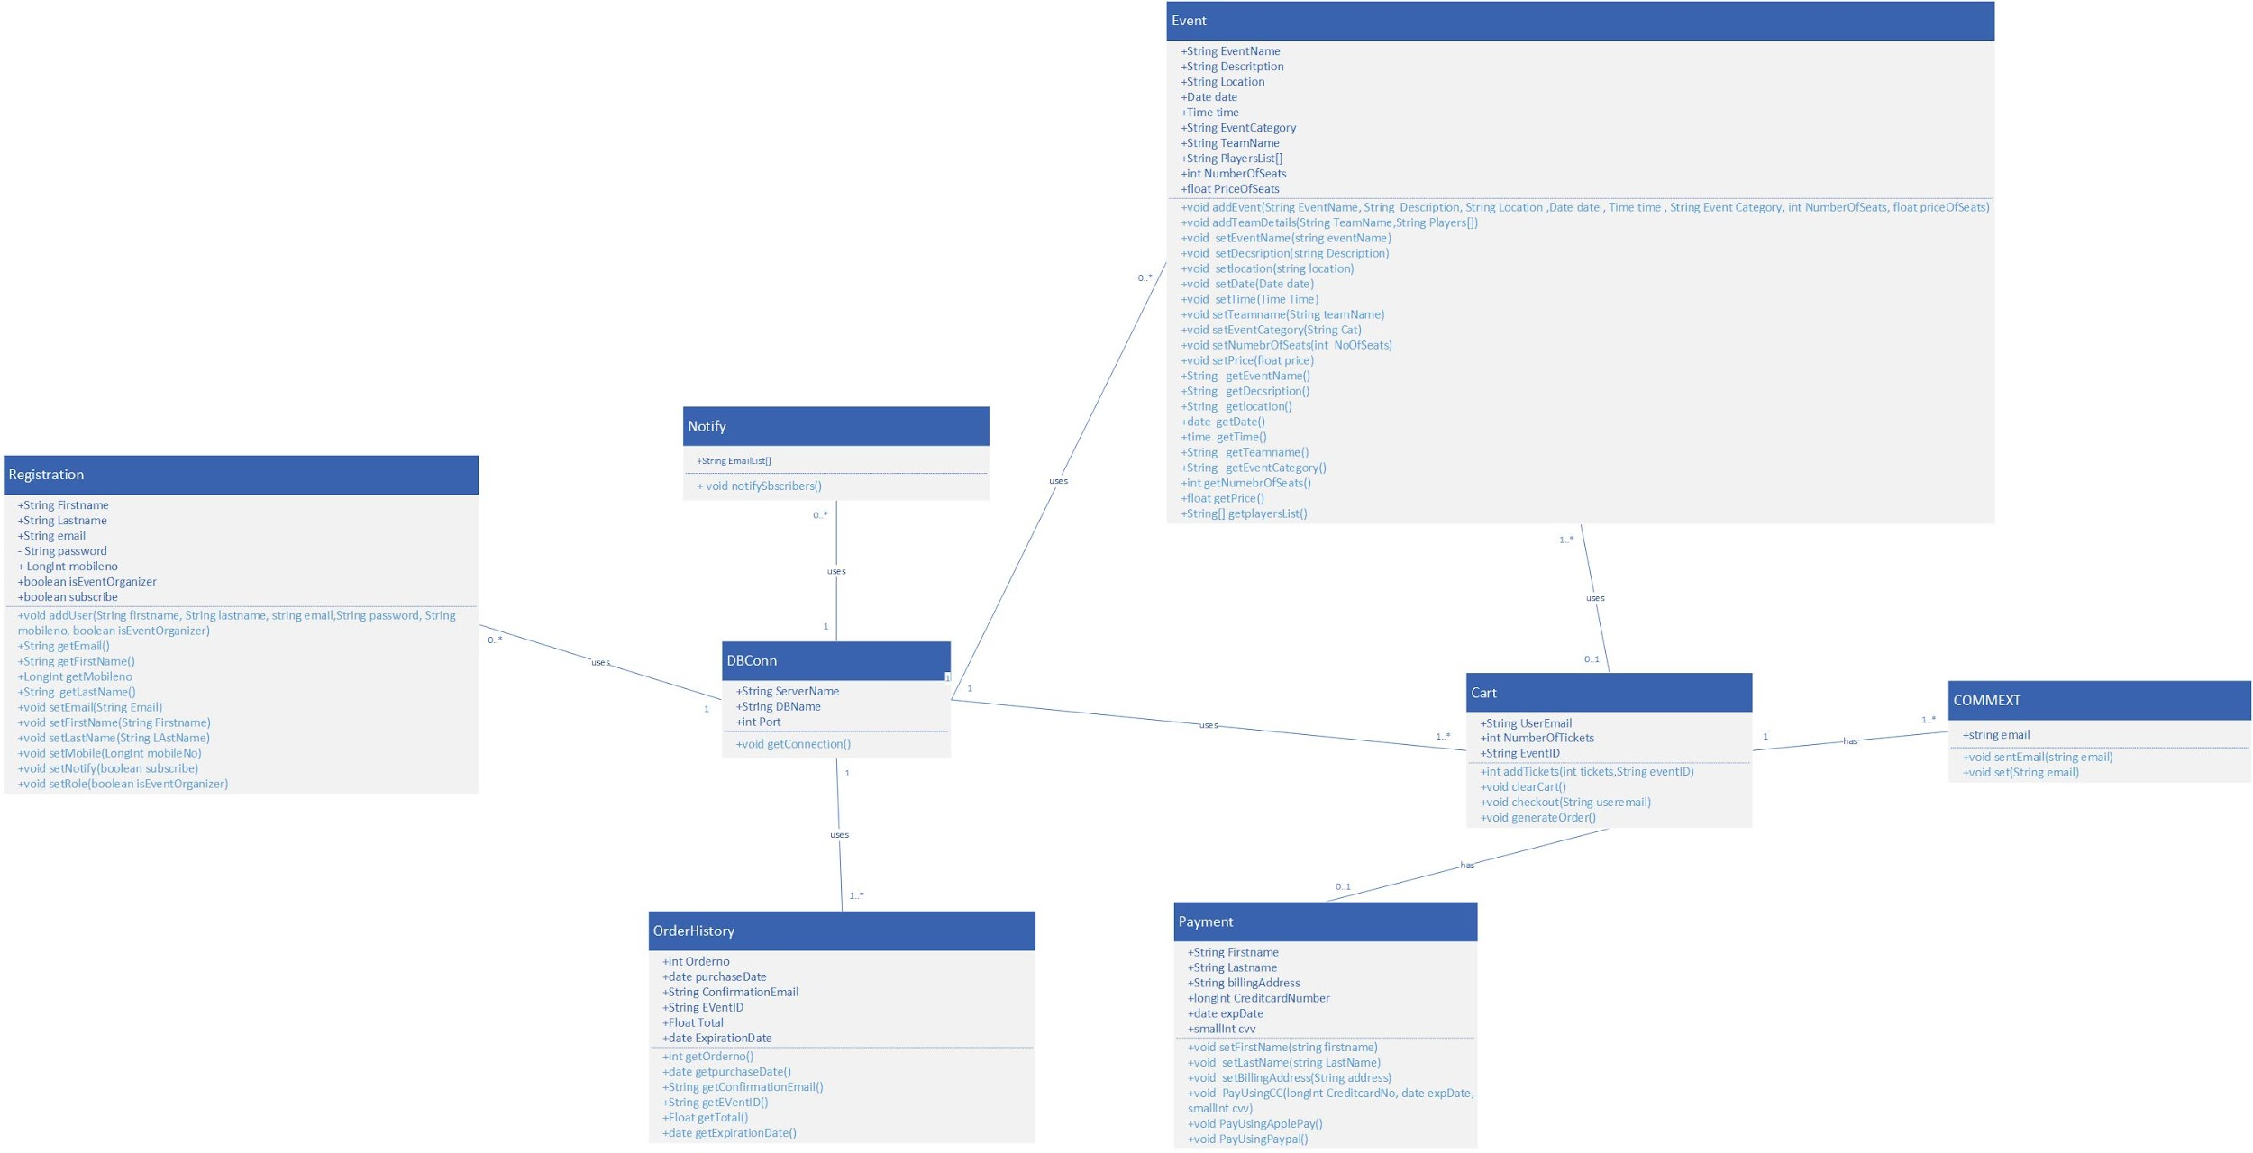

**Package Diagram**

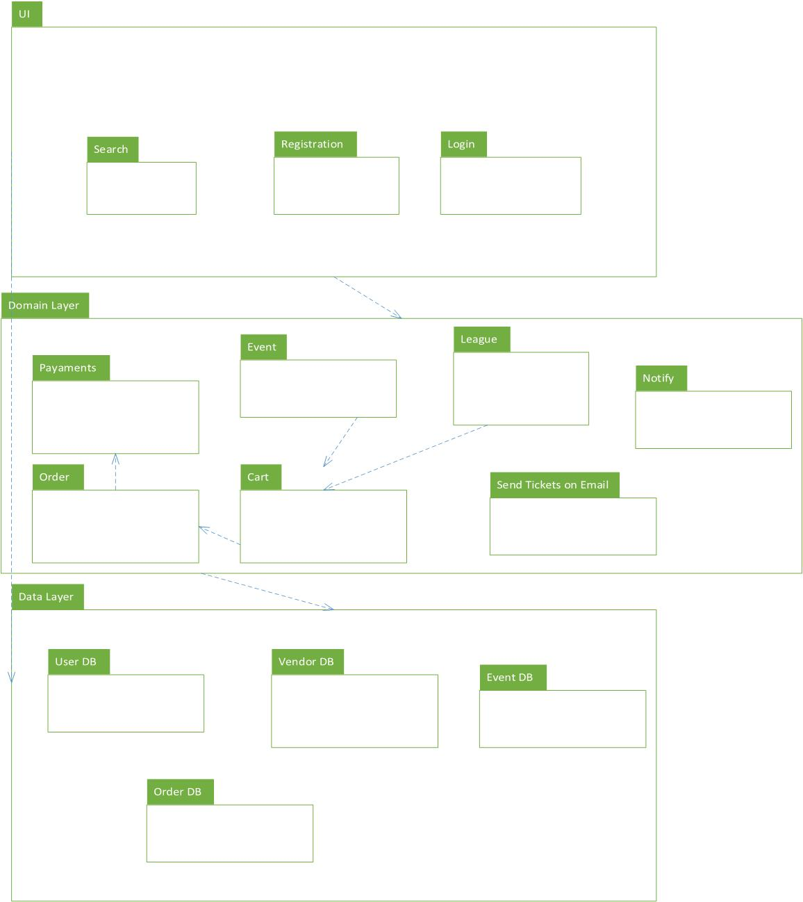

**System Sequence Diagrams**

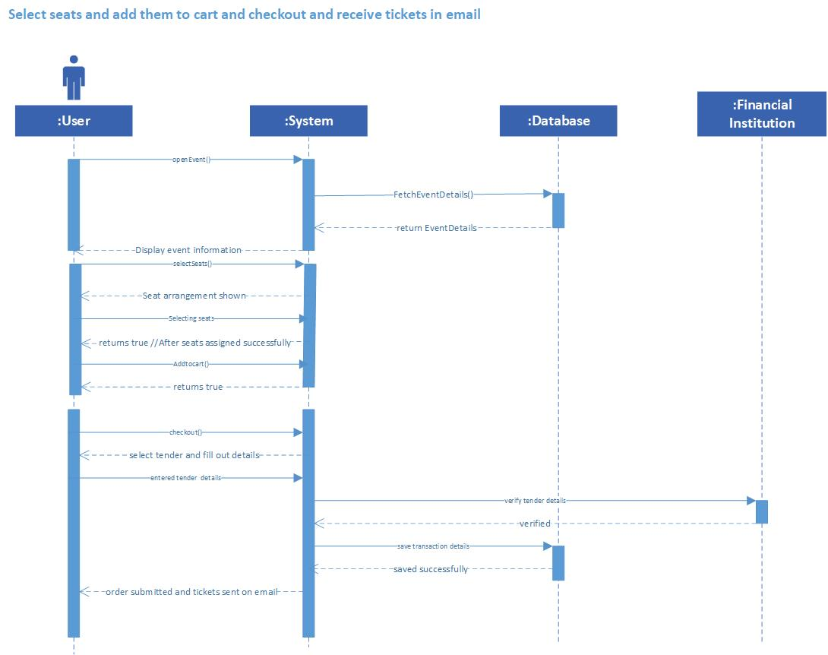

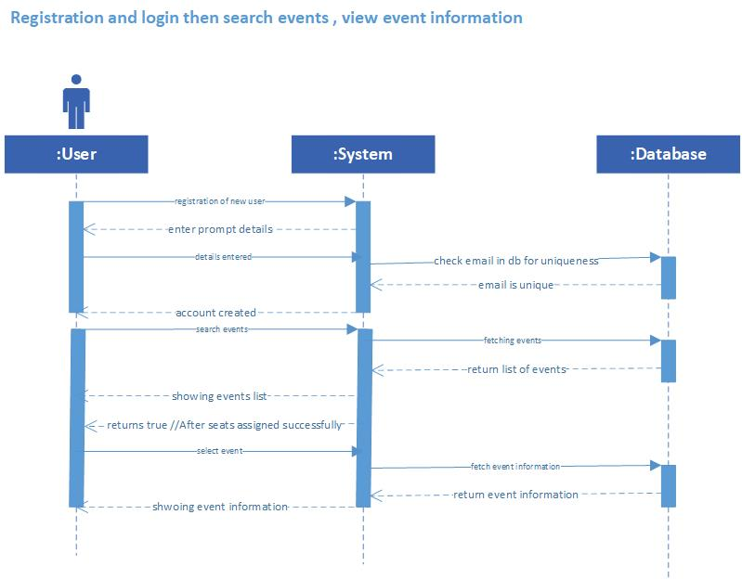

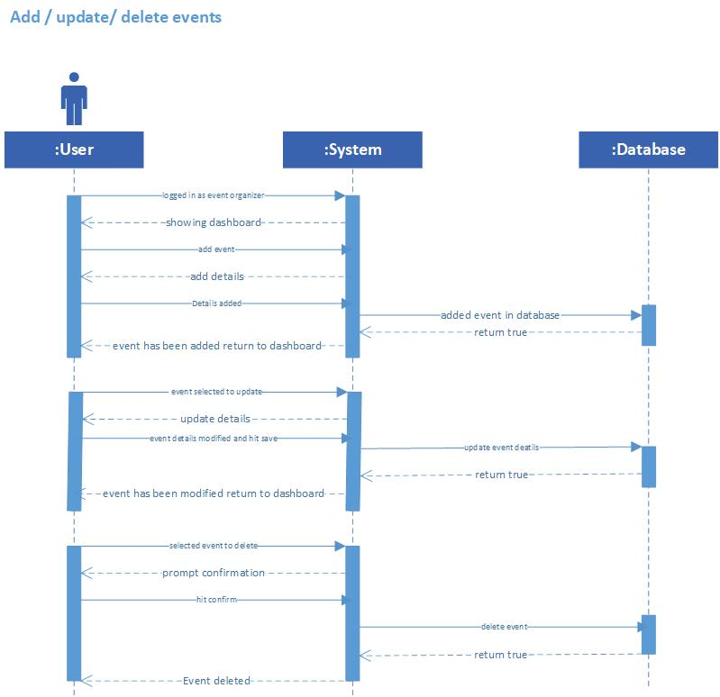

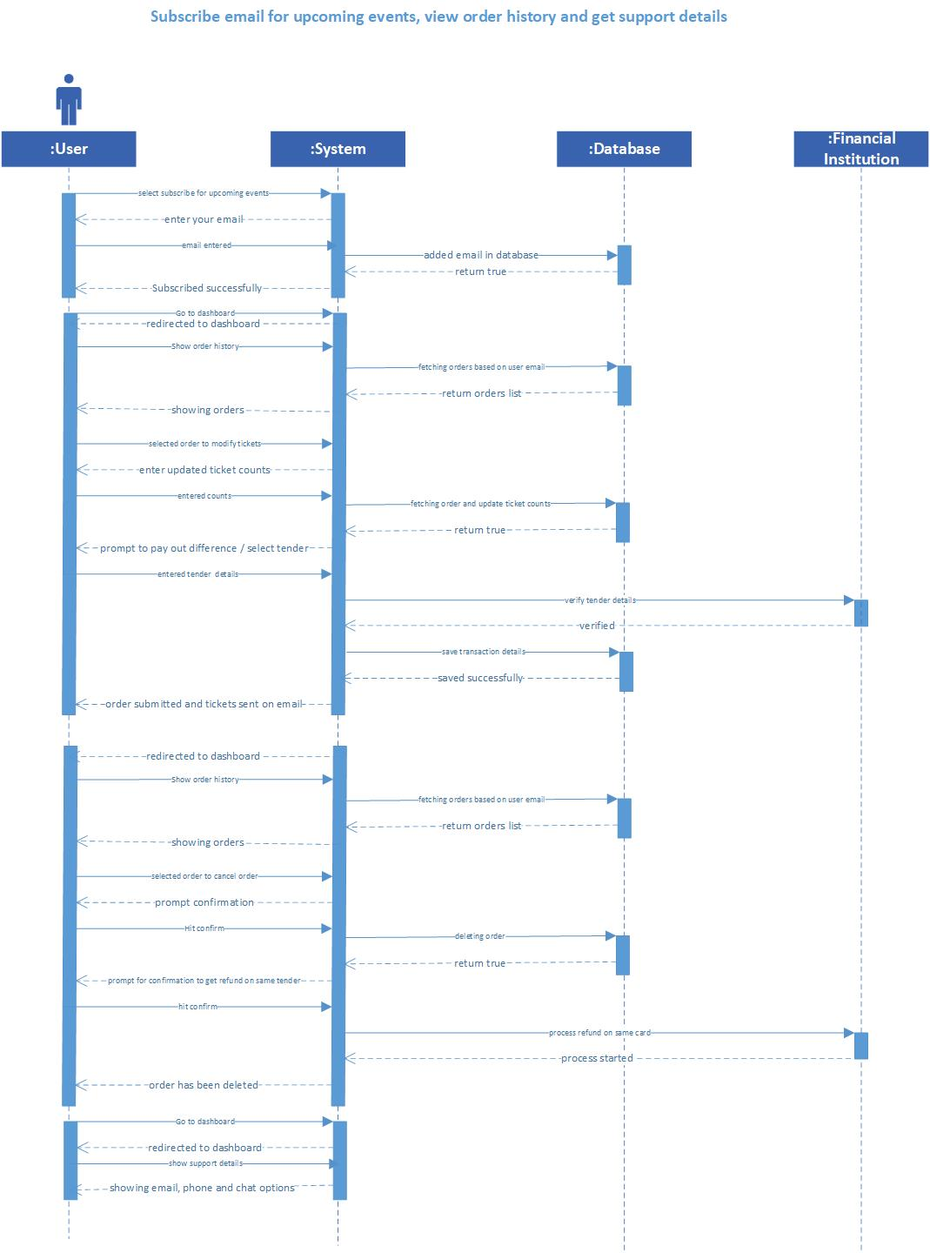

**System Interaction Diagram**

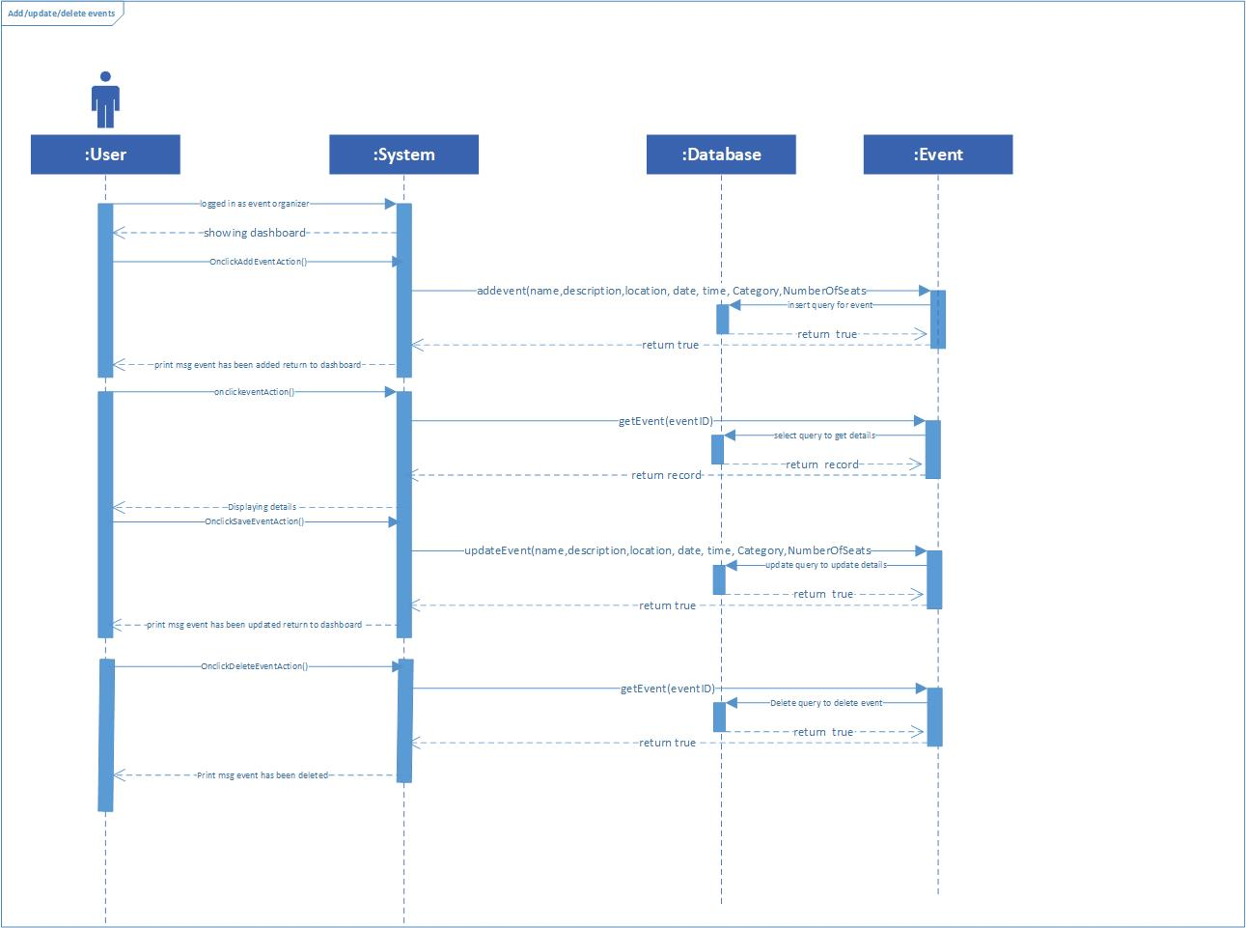

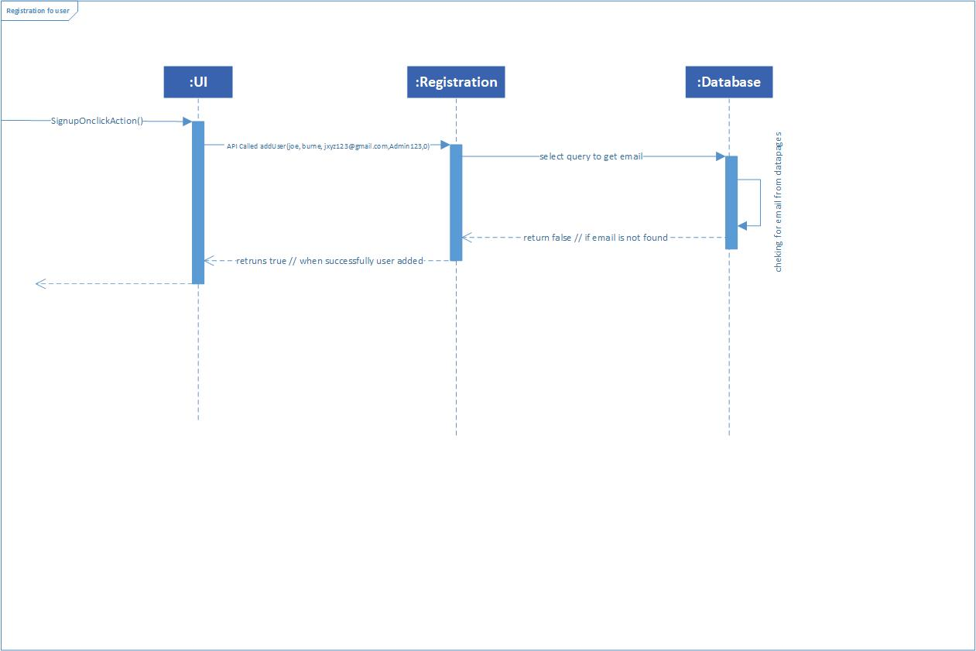

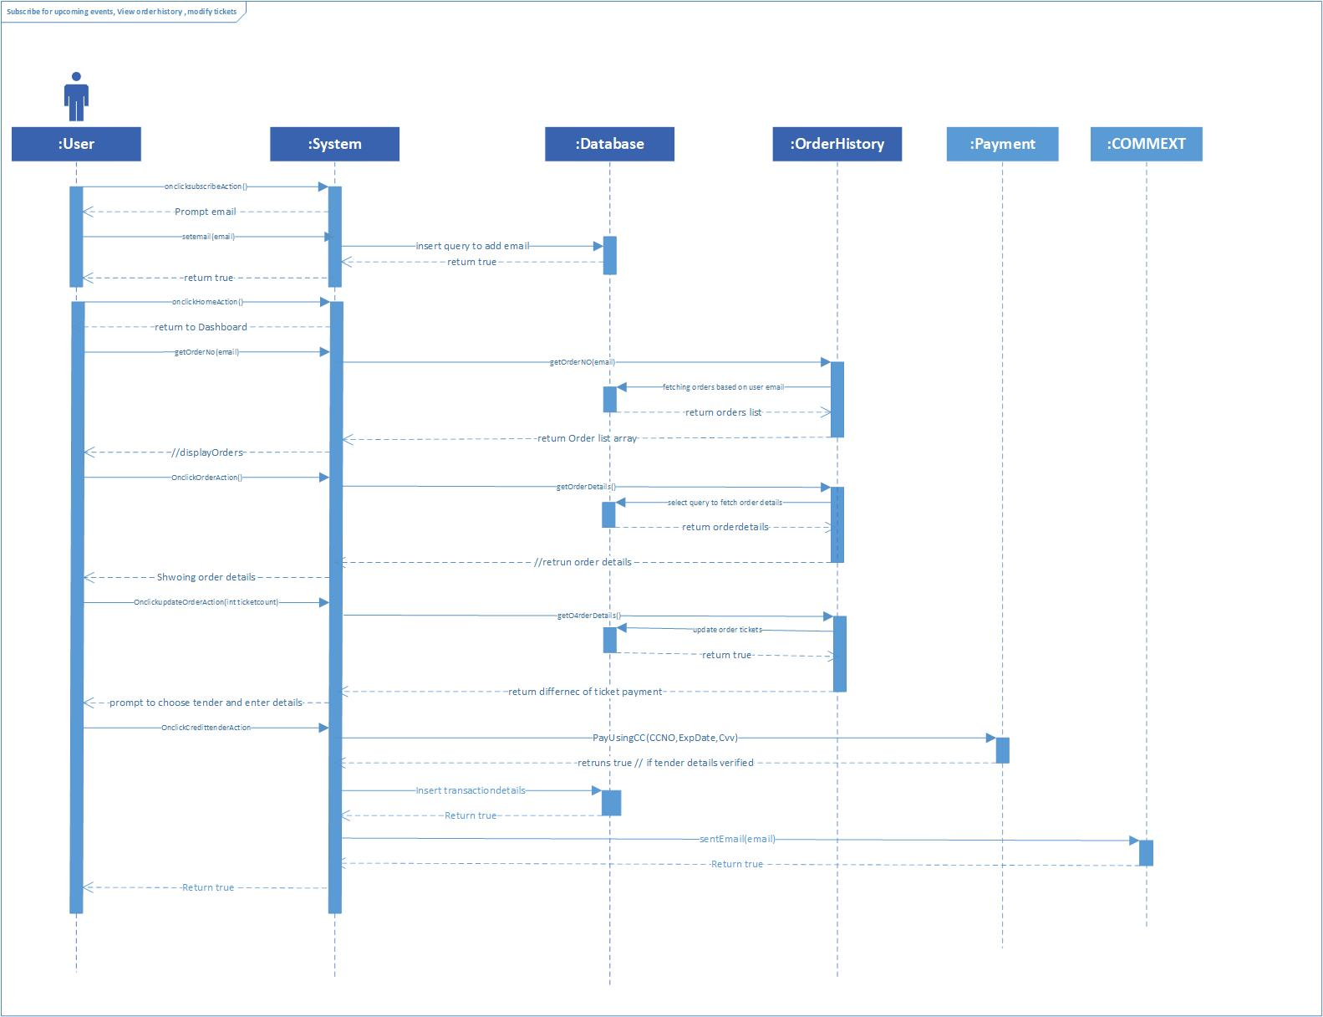

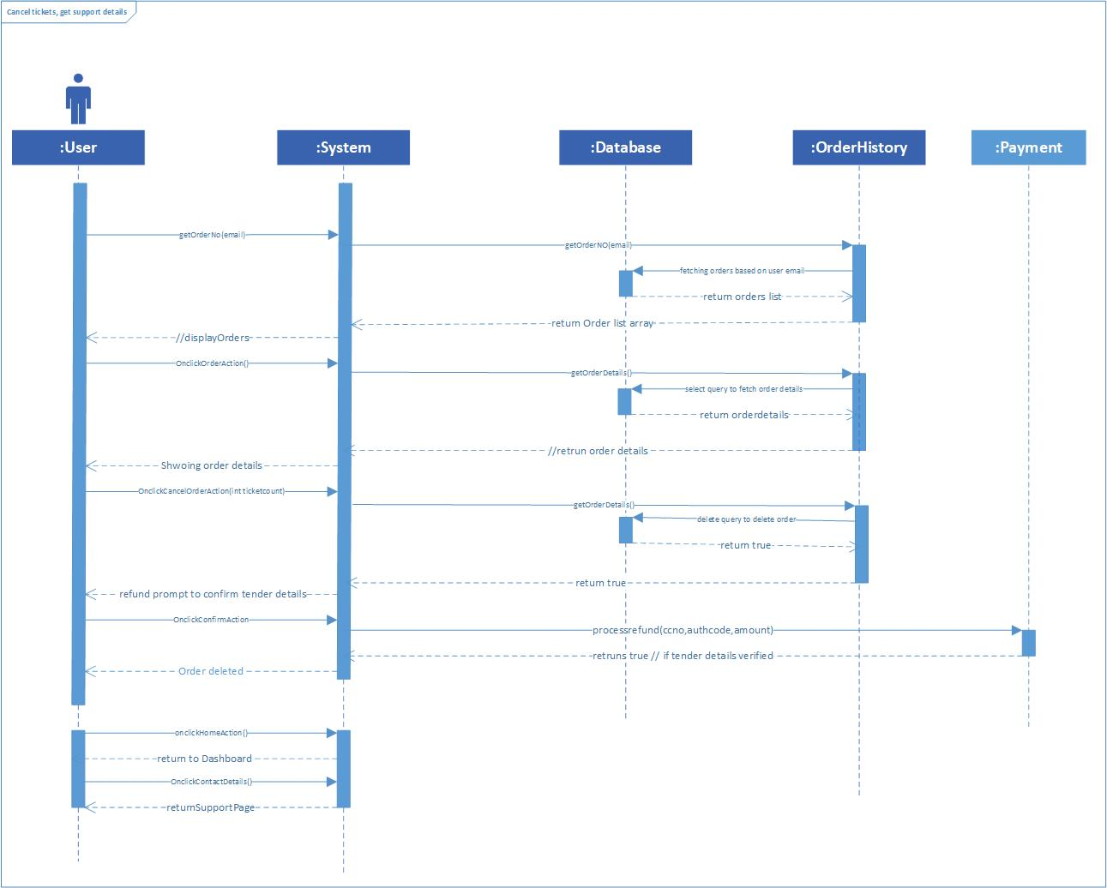

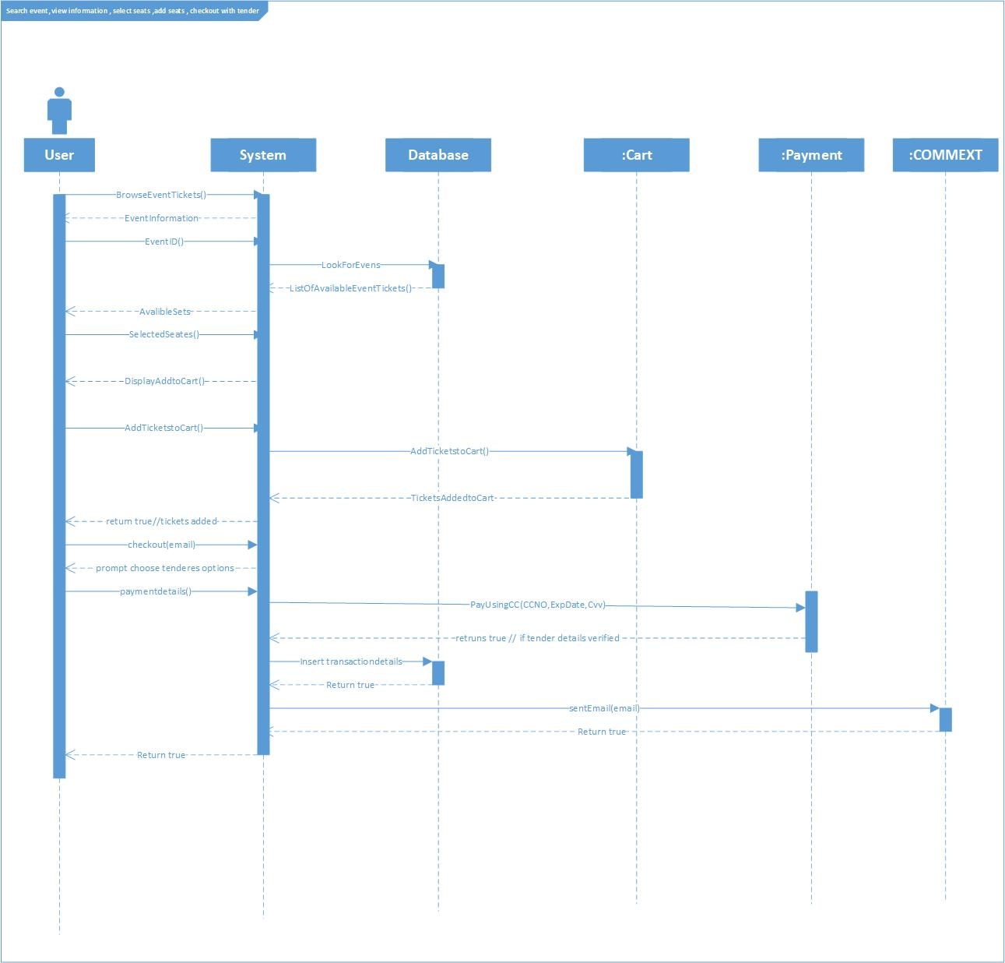

**Design Patterns:**

1. **Observer Pattern**

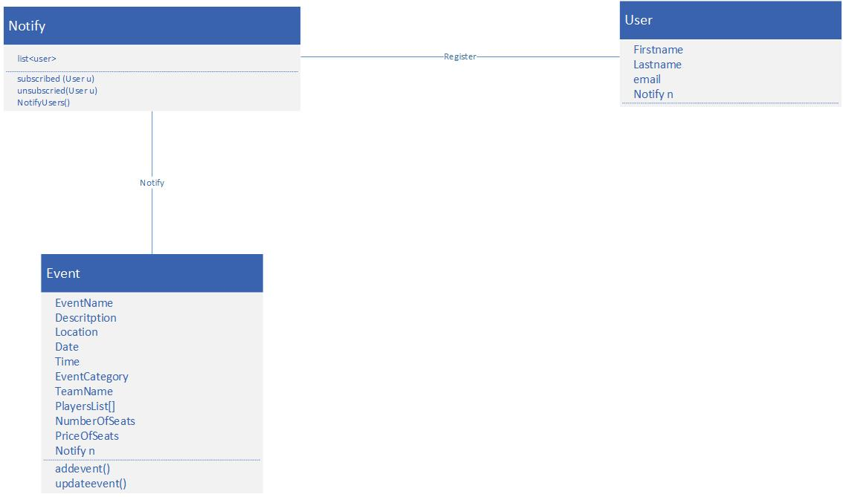

1. **Factory Method Pattern**

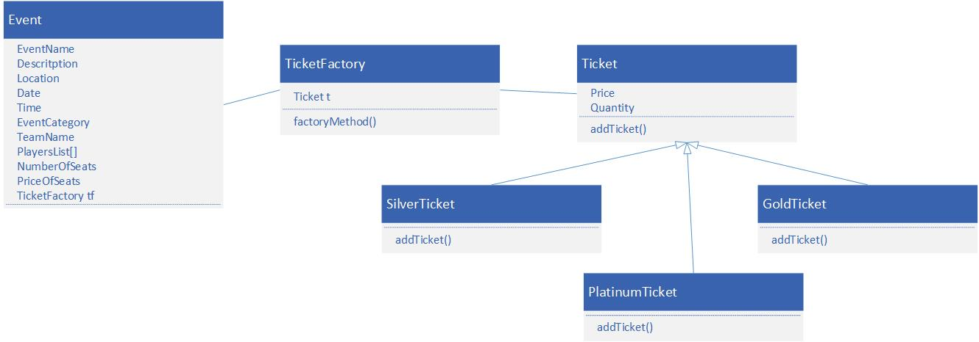

1. **Strategy Pattern**

